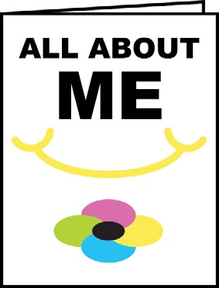
Use the OSP to Support the Development of the “All About Me” Portfolio, Kindergarten to Grade 6

Here is a chart which outlines how these OSP resources relate to each
of the education and career/life planning inquiry questions.

 | Kindergarten to Grade 3 | Grades 4 to 6
Who am I? | Complete My Essential Skills – Primary  Complete My Work Habits – Primary  Use a Pan Am/Parapan Am problem-based learning activity focused on the skills you want to develop | Complete My Essential Skills – Junior  Complete My Work Habits – Junior  View Discover Your Skills Video  on SkillsZone.ca  Use a Pan Am/Parapan Am problem-based learning activity focused on the skills you want to develop
What are my opportunities? |  | Post Using Essential Skills and Work Habits in Volunteer Jobs at School – Use these sample “job postings” to help show students how they can demonstrate and track their Learning Skills and Work Habits, OSP Work Habits and Essential Skills in different school jobs such as “Kindergarten Helper” and “Bus Patrol.”
Who do I want to become? | Use Connecting Essential Skills and  Work Habits to Guest Speakers | Use Connecting Essential Skills and  Work Habits to Guest Speakers  Research a Career – See how workers use  Essential Skills on the Job. Complete Essential Skills in Jobs and Career Reflection Worksheet.
What is my plan for achieving  my goals? |  | Use the Learning Skills and Work Habits - Setting Goals to Keep Improving  Complete the Ontario Skills Passport Reflection Worksheet after finishing a Volunteer Job at School.

